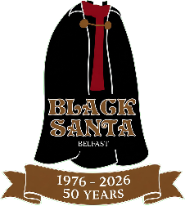
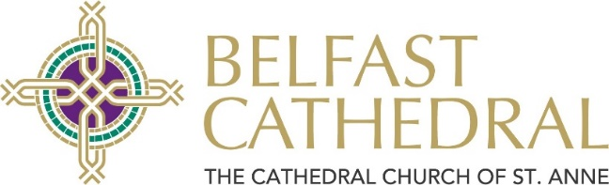
Black Santa 50th Anniversary Application Form 2026
Please complete all four sections using block capitals. This form can be submitted digitally. Please refer to important Terms & Conditions at end of the application form.
- Due to the large number of applications expected, we will not normally process any late applications.

- In order to maximise individual grants awarded, applications will only be considered from charities whose Northern Ireland income in 2025 was £250,000 or less.
- We request that multiple applications are not submitted from the same organisation – Please note only one grant will be awarded for each individual NI Charity Number.
- Due to existing commitments we are unable to donate to any more projects abroad.

- Grants will only be awarded to organisations who can provide a registered charity number and registered accounts for 2025 as submitted to the Charity Commission.
- Completed forms must be submitted by 5.00pm on Friday 11th December 2026 at the latest and posted to The Dean of Belfast, Sitout Applications, c/o Ms Cate Cox, Belfast Cathedral, Donegall Street, Belfast, BT1 2HB. Alternatively, please email to admin@belfastcathedral.org.
This year for the 2026 Fiftieth Anniversary Sitout Appeal, the Dean welcomes applications from local registered charities with an income in 2025 of £250,000 or less.

Section 1 – Contact Details
Has the organisation been successful in applying to the sitout before? Y / N
Name of Organisation:
Key Contact:

Address:

Postcode:
Telephone No:
Email:
Website:
Date organisation was established:

Section 2 – Organisation Financial Details
Please include a set of audited accounts for the last complete year.
Note, applications cannot be considered without 2025 Accounts submitted.
NB BACS Account Details
For Electronic Bank Payment
(Check that all details are listed correctly to avoid payment delay)
Exact Account Name:
Account Sort Code:
Account Number:
OR Name of account that a cheque is to be made payable to:
Number of Staff: | (Paid) | (Volunteers)
Number of individuals benefitting from grant:
Gross (Northern Ireland) Income 2025:  (£250,000 or less) | £
Gross (NI) Expenditure 2025: | £
Gross (Outside NI) Income 2025: | £
Gross (Outside NI) Expenditure 2025: | £
Northern Ireland Charity Number(Required Information for successful application):

- Section 3 – Grant Category
A – Listed Charitable Purposes
Section 4 – Organisation Description
In the space below, please give a brief summary of the work your organisation undertakes and indicate the specific uses to which any grant from the Sitout would be put. (Please ensure information is legible and contained within the box. Continue on the next page if required).

Section 4 – Organisation Description (Continued)
I

Terms and Conditions
- All grants awarded must be separately identified as received from ‘St Anne’s Cathedral Sitout’ within the annual accounts or Annual Report of the organisation.
- Any grant awarded is given appropriate publicity and acknowledgement in the organisation’s relevant documentation. A digital version of the Cathedral’s logo is available on request.
- All grant awards will be distributed at The Good Samaritans’ Service held in St Anne’s Cathedral on Sunday 7th February 2027 starting at 3.30pm. Please note, it is an award requirement for at least one representative of your organisation to attend this service if your application is successful. We regret that if no member of your charity or organisation is present in person at the Good Samaritan Service to receive your award from the 2026 Sitout, then the award cannot be made.
- Please check (and recheck) that BACS details you have provided are correct. (Full Account Name, Bank Sort Code & Bank Account Number). Only in exceptional circumstance will the award be made by cheque in which case, your cheque should be presented to your bank without delay.
- Please be aware that in the case of successful applicants, information given in Section 4 may be used by St Anne’s Cathedral to publicise future Black Santa Sitouts and/or Good Samaritans’ services.
Declaration
I confirm that I have read and understood the above terms and conditions, and that at least one representative from this charity will be present at the Good Samaritans’ Service on Sunday 7th February, 2027 to receive the award, if successful:-
Signed |  |  | Date
Print Name |  |  | Position in organisation

